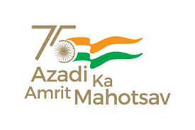

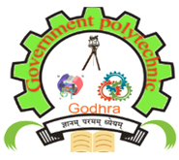
A
Report
on
“Awareness, Ideathon & Group Discussion” program
Under
Student Startup Research and Innovation Festival

Venue  Shaheed Bhagatsinh Auditorium  Government Polytechnic,  Godhra | Date: 07-10-2022  Time: 11:00 am onwards
SSIP Cell, Government Polytechnic, Godhra

SSIP 2.0 Awareness, Ideathon & Group Discussion program was organized by SSIP Cell, Government Polytechnic Godhra on Friday, 7th October, 2022 under Azadi ka Amrit Mahotsav. These programs were organized to sensitize students of the institute. Students of all the three departments Civil, Mechanical and Electrical and of all the 3 levels participated enthusiastically in the program.

Awareness program started at 11:15 am as per the minute to minute program scheduled and followed by Ideathon and group discussion program. Principal Shri Dr. J V Bholanda welcomed the chief guest Mr. Sanjay Soni (President of Nagarpalika, Godhra), guest of honour Mr. Devang Soni (HR, R B Cars Pvt. Ltd.) and honourable speaker Dr. Amit Patel (Asst. Prof. Physics at GEC Godhra).

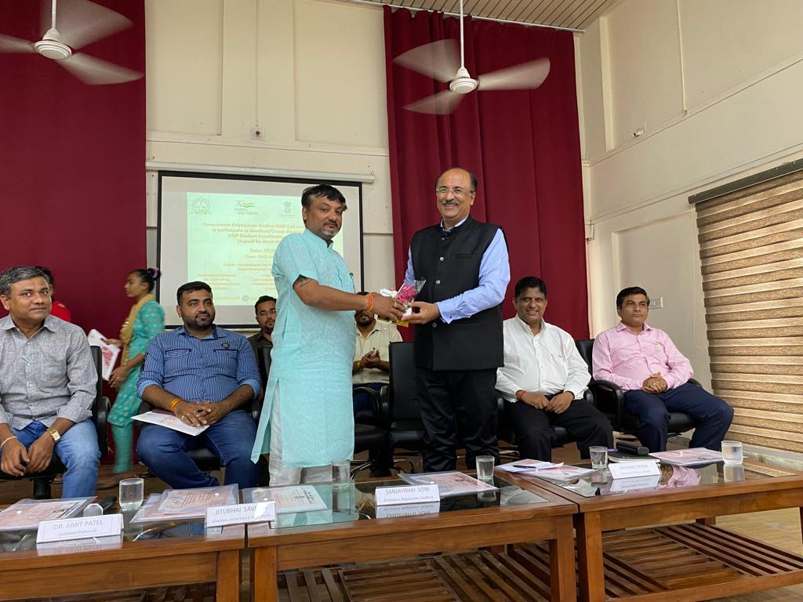
Principal Shri Dr. J V Bholanda welcomed the chief guest Mr. Sanjay Soni (President of Nagarpalika, Godhra)

After that Mr. S. M. Gandhi (Head SSIP committee & HOD Mechanical) briefly explained various activities carried out at institute under SSIP 1.0 and future planning under SSIP 2.0. Mr. Sanjay Soni (President of Nagarpalika, Godhra) delivered valuable speech on Startup as a chief guest. Mr. Devang Soni (HR, R B Cars Pvt. Ltd.) motivated students towards job seeker to job giver through entrepreneurship. Felicitation of SSIP 1.0 beneficiary was carried out along with successful entrepreneur of institute Mr. Ravi Pandya (Prop. Pandya Industries Pvt. Ltd.) and Mr. Saiyed Shafikali (Prop. SSS Empire consulting firm). Dr. Amit Patel (Asst. Prof. Physics at GEC Godhra) explored the various aspects of the SSIP 2.0 during his keynote speech.
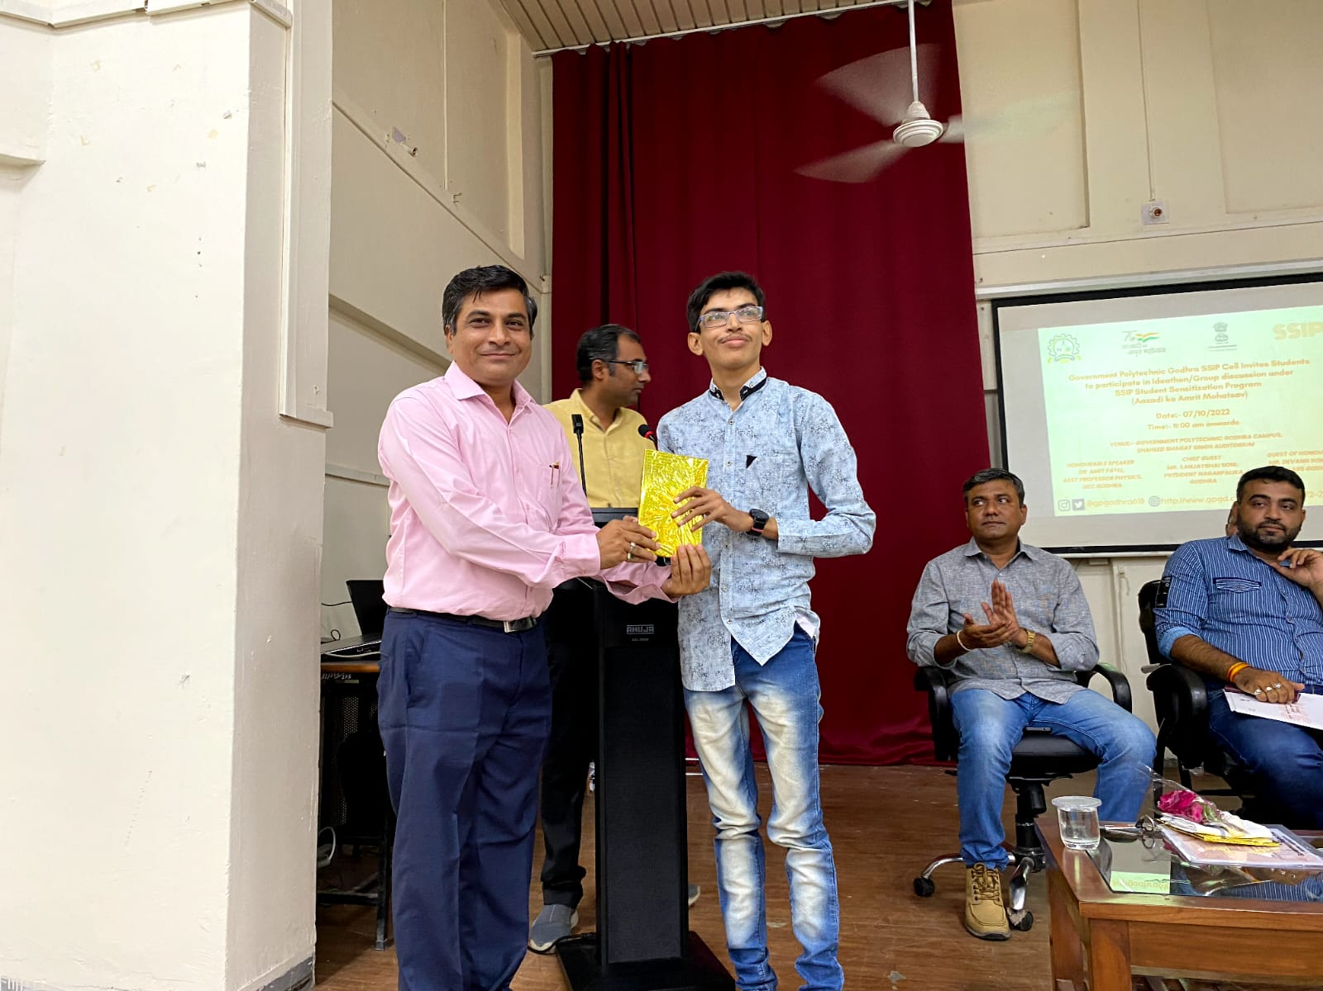
Felicitation of SSIP 1.0 beneficiary
(Meet Maheta, 2022 pass-out Mechanical student)

For Ideathon program, registration was carried out well in advance through online form. Total 05 no. of groups comprising of total 20 students participated in Ideathon. Poster paper presentation was carried out to present the innovative ideas of the students. Winner certificates along with prizes as well as participation certificates were given to the students.

Ideathon program

For Group discussion program, two topics were selected:
(1) Roll of SSIP to generate employment in our country
(2) Not everyone gets an opportunity to become an entrepreneur
Registration was carried out well in advance through online form. Total 16 students participated in group discussion. Winner certificates along with prizes as well as participation certificates were given to the students. Dr. Amit Patel (Asst. Prof. Physics at GEC Godhra) moderated the program effectively.

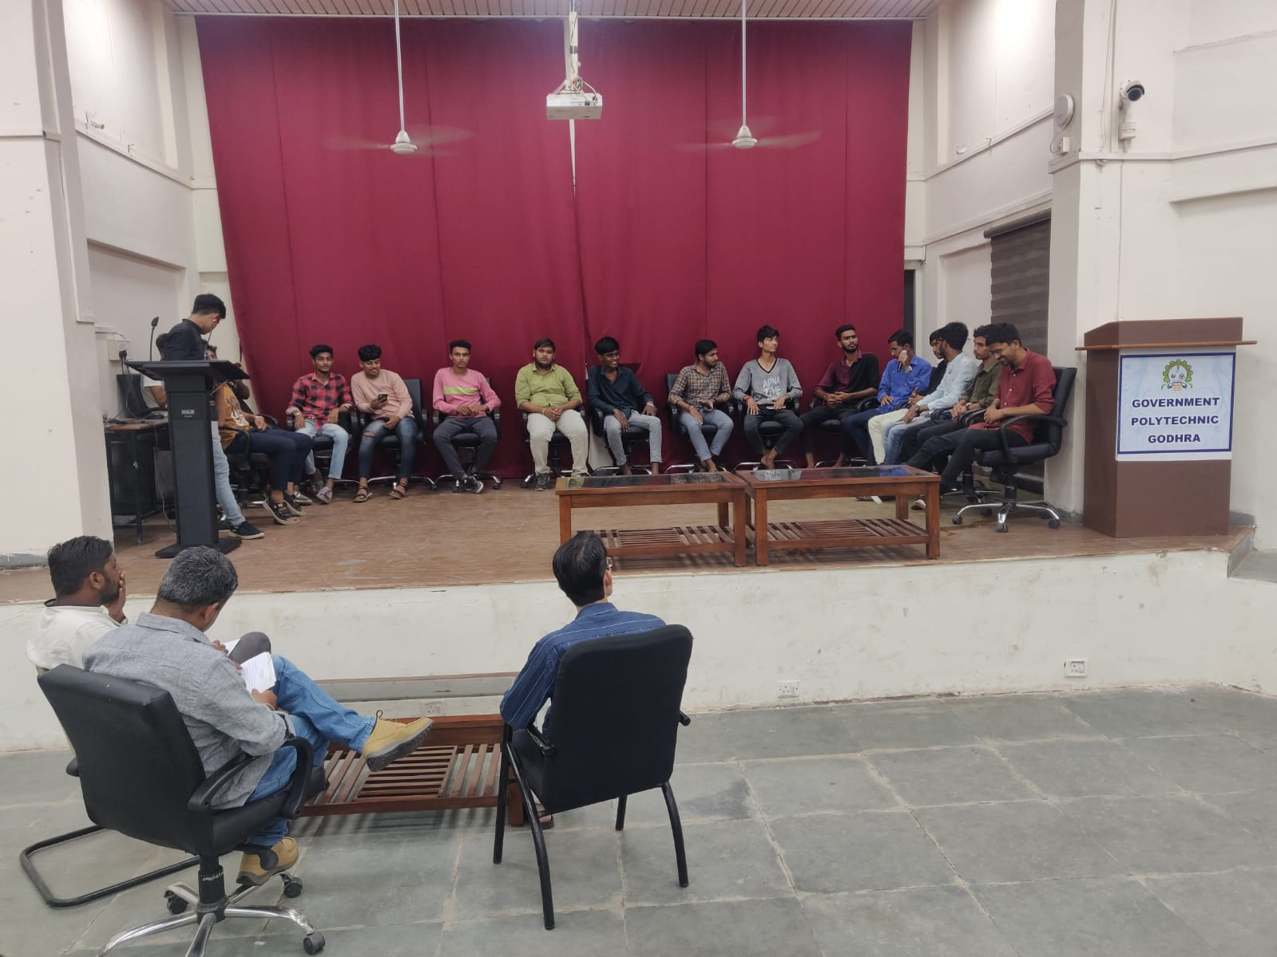
Group Discussion program

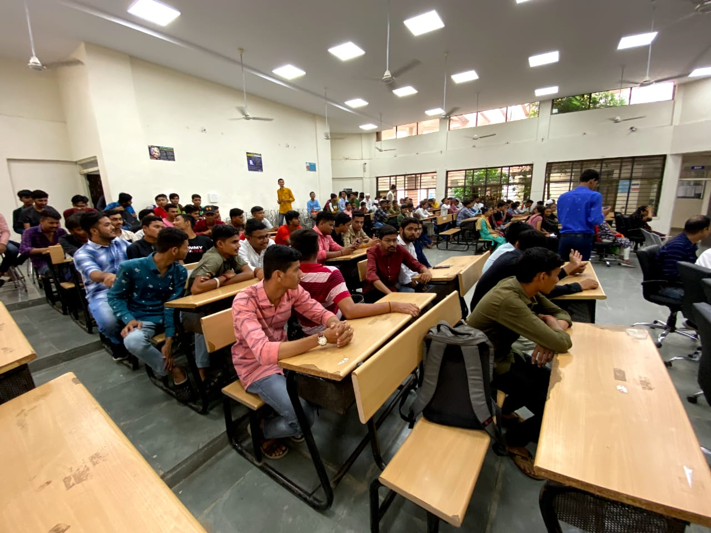 | 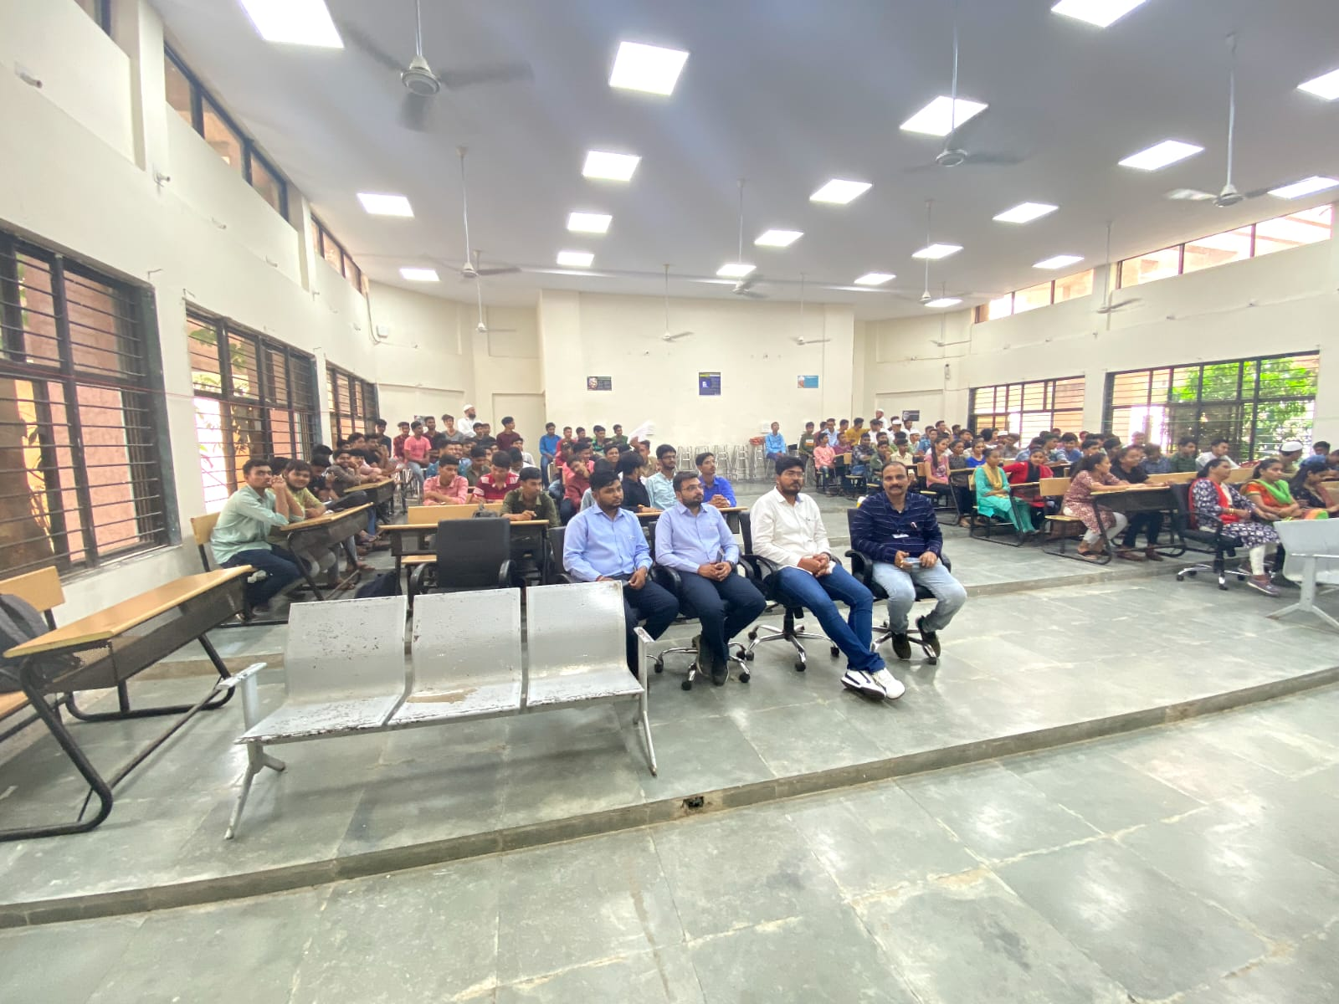
Program Glimpse

